Rob (Techno) Spargo
Threetahlee@hotmail.com

Fog Lights On Indicator for NB8B's
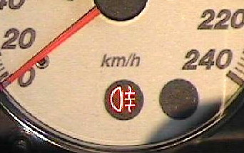
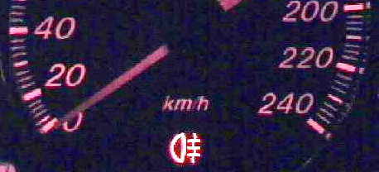
The NB8B has factory fitted fog lights but there is no light on the dash to show if the fog lights are on.

However, the display indicator located under the KPH lettering on the NB8B series cars is actually a fog light symbol. Unfortunately, Australian delivered cars have no wiring or globe mounted behind that display indicator.

Here is how to get that dash light functioning.

The tools and supplies you need are:
- 2 X 70cm lengths of auto electric wire.
- Some insulation tape (I use some cable ties too)
- Phillips head screw driver
- Pliers
- 2 X 2.8mm mini male spade lugs (part number H5038 from Dick Smith's)
- a globe holder (Bezel Round part number P8056 from Dick Smith's)
- A soldering iron
and about 37 minutes

Cut the wires to length and attach the spade lugs.  Cut two sections of wire each 70cm long.  - Strip the ends back 5mm.  - Attach the spade lug to each wire so that the first clip is on the plastic coating and the second on the wire.  - Clamp down tightly with the pliers.  - Apply a dab of solder. | 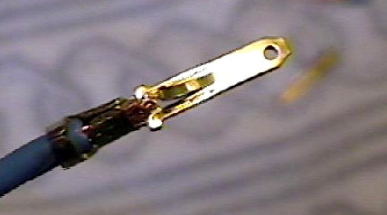
Unscrew the black section from the P 8056 assembly.  - Unscrew the top section of the bulb holder and discard; it's only the black section that we use.  - Remove the globe before soldering as heat can damage the filament | 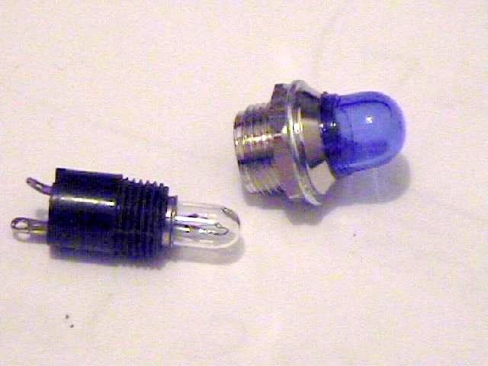
Solder the wires to the globe holder.  - Wrap each join with insulation tape, and tape over both wires to hold them firm. | 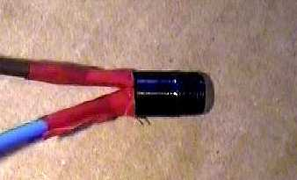
Apply one layer of insulation tape to the outside of the bulb holder.  This will make it a firmer fit in the instrument panel hole.  - Apply cable ties to keep wires together.  - Replace the globe.  - Test the circuit using a 9-volt torch battery. | 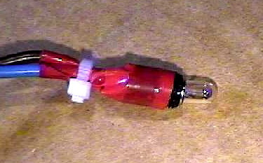
Remove the cover to the fuse panel and reach up and push the fog light switch forward and out. | 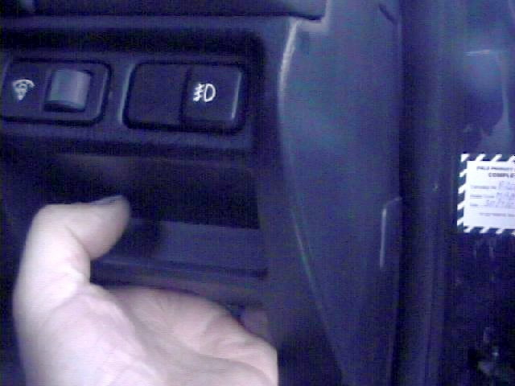
Insert the wires into the white junction box.  There are four wires entering the fog light switch. The ones that we connect to are on the side without the junction box clip.  The wires are coloured  - White and green stripes  - White and red stripes  Insert the spade lug between the existing clip and the plastic side.  - Push the spade lugs all the way down so that they are firmly in place.  - Switch on the lights and the fog lights and the globe should glow. If it doesn't then check the wiring and the globe.  Turn off the lights and the ignition. | 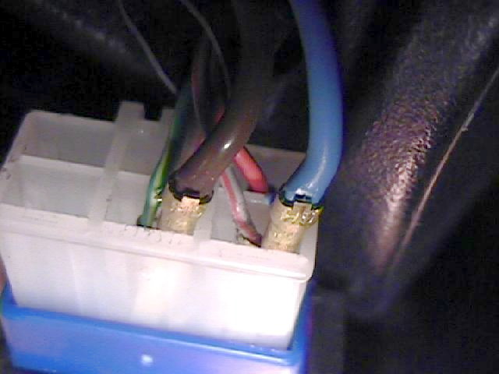
Remove the top steering wheel column cowl. There are no screws, it just clips into the bottom section. Pull it up from the front and press in the sides and the top cowl part will loosen. | 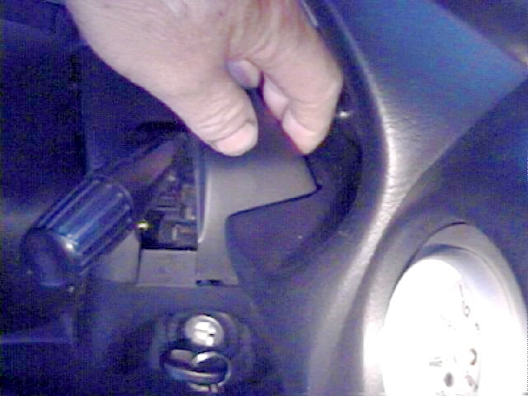
Remove the dash cowl.  There are no screws, just clips at the front and rear (see picture). The gap between the glass and the cowl is just enough to get a grip.  So grab the section through the steering wheel and pull sharply forward to release the clips (this may take some effort).  Bring the cover forward only about 20mm then release the clips on the lower sides of the cover and then the total covering can be removed. | 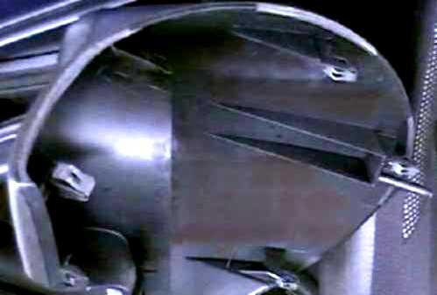
Remove the instrument panel.  There are 4 Phillips head screws to remove.  Pull the instrument panel forward, there is a wiring loom which needs to be unclipped from its holder to the dash padding. | 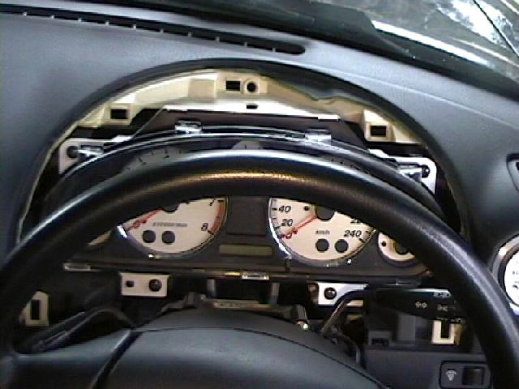
Fit the globe holder.  You can now pass the globe holder up behind the dashboard and into the area behind the instrument panel.  Do not touch the printed circuits on the back of the panel. Find the hole for the bulb holder. (Hint:-it's the only vacant hole)  Fit the bulb holder into the hold and push/screw so that it is firmly in place. Use cable ties to attach the new wires to the wiring loom.  Test the circuit by turning on the lights and fog lights.  Sit the instrument panel back into place (secure the wiring loop clip again to the dash padding) | 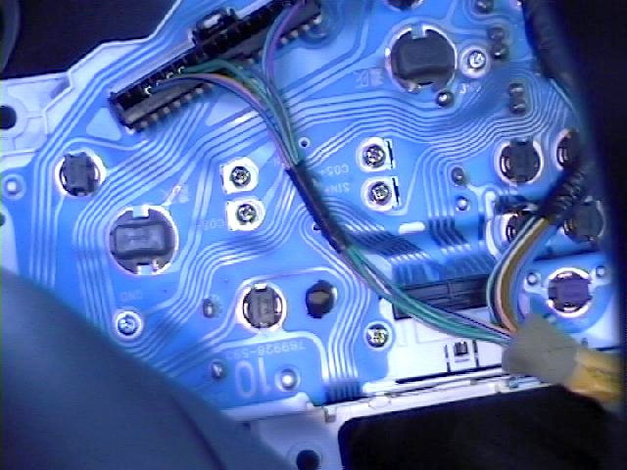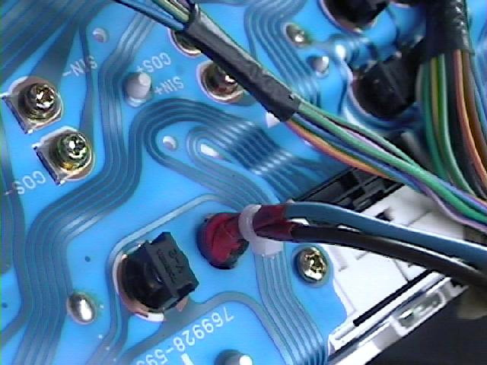
Reassemble the dash and panels

All done, now enjoy your new found light.

Safe journey

Rob (Techno) Spargo
October 2003

